**Assignment 1:Create an infographic illustrating the Test-Driven Development (TDD) process. Highlight steps like writing tests before code, benefits such as bug reduction, and how it fosters software reliability.**

→ Test-driven development (TDD) is defined as an iterative methodology that prioritizes the creation of and checking against test cases at every stage of software development, by converting each component of the application into a test case before it is built and then testing and tracking the component repeatedly.

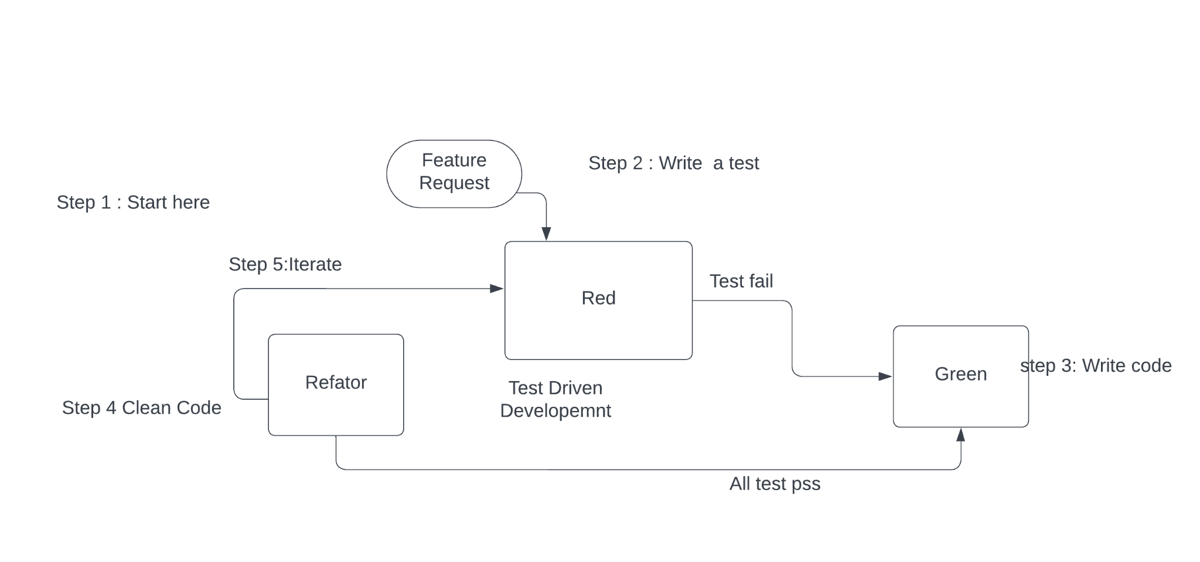

* 2. In TDD, developers create small test cases for every feature based on their initial understanding. The primary intention of this technique is to modify or write new code only if the tests fail. This prevents duplication of test scripts.

Examples:-

* Calculator Function: When building a calculator function, a TDD approach would involve writing a test case for the “add” function and then writing the code for the process to pass that test. Once the “add” function is working correctly, additional test cases would be written for other functions such as subtract, multiply and divide.

### Phases of TDD:

**1.Write a Test**

* Write a test for the new feature or functionality.

**2.Run All Tests**

* Run all tests to see the new test fail.

**3.Write the Code**

* Write the minimum amount of code to pass the new test.

**4.Run Tests Again**

* Run all tests to see them pass.

**5.Refactor**

* Refactor the code to improve its structure and efficiency.

**6.Repeat**

* Repeat the cycle for new features or functionalities.

**Benefits of TDD:**

* **Bug Reduction:** Early detection and fixing of bugs during development.
* **Code Quality:** Encourages writing cleaner, more modular, and well-documented code.
* **Software Reliability:** Frequent testing ensures that the software behaves as expected.
* **Documentation:** Tests serve as a form of documentation for the codebase.
* **Development Efficiency:** Reduces time spent on debugging and maintenance in the long run.

**Advantages:**

**1.**It improves the code quality.

2.It reduces the bugs

**Disadvantages**:

1.Time consuming process.

2.Developing test cases of every scenario is difficult.